**JUnit Testing Exercises**

Exercise 1: Setting Up JUnit

Scenario:

You need to set up JUnit in your Java project to start writing unit tests.

Steps:

1. Create a new Java project in your IDE (e.g., IntelliJ IDEA, Eclipse).

2. Add JUnit dependency to your project. If you are using Maven, add the following to your

pom.xml:

<dependency>

<groupId>junit</groupId>

<artifactId>junit</artifactId>

<version>4.13.2</version>

<scope>test</scope>

</dependency>

3. Create a new test class in your project.

pom.xml

<?xml version="1.0" encoding="UTF-8"?>

<project xmlns="http://maven.apache.org/POM/4.0.0" xmlns:xsi="http://www.w3.org/2001/XMLSchema-instance"

  xsi:schemaLocation="http://maven.apache.org/POM/4.0.0 http://maven.apache.org/xsd/maven-4.0.0.xsd">

  <modelVersion>4.0.0</modelVersion>

  <groupId>com.example</groupId>

  <artifactId>testing</artifactId>

  <version>1.0-SNAPSHOT</version>

  <name>testing</name>

  <!-- FIXME change it to the project's website -->

  <url>http://www.example.com</url>

  <properties>

    <project.build.sourceEncoding>UTF-8</project.build.sourceEncoding>

    <maven.compiler.source>1.8</maven.compiler.source>

    <maven.compiler.target>1.8</maven.compiler.target>

  </properties>

  <dependencies>

    <dependency>

      <groupId>junit</groupId>

      <artifactId>junit</artifactId>

      <version>4.11</version>

      <scope>test</scope>

    </dependency>

  </dependencies>

  <build>

    <pluginManagement><!-- lock down plugins versions to avoid using Maven defaults (may be moved to parent pom) -->

      <plugins>

        <!-- clean lifecycle, see https://maven.apache.org/ref/current/maven-core/lifecycles.html#clean_Lifecycle -->

        <plugin>

          <artifactId>maven-clean-plugin</artifactId>

          <version>3.1.0</version>

        </plugin>

        <!-- default lifecycle, jar packaging: see https://maven.apache.org/ref/current/maven-core/default-bindings.html#Plugin_bindings_for_jar_packaging -->

        <plugin>

          <artifactId>maven-resources-plugin</artifactId>

          <version>3.0.2</version>

        </plugin>

        <plugin>

          <artifactId>maven-compiler-plugin</artifactId>

          <version>3.8.0</version>

        </plugin>

        <plugin>

          <artifactId>maven-surefire-plugin</artifactId>

          <version>2.22.1</version>

        </plugin>

        <plugin>

          <artifactId>maven-jar-plugin</artifactId>

          <version>3.0.2</version>

        </plugin>

        <plugin>

          <artifactId>maven-install-plugin</artifactId>

          <version>2.5.2</version>

        </plugin>

        <plugin>

          <artifactId>maven-deploy-plugin</artifactId>

          <version>2.8.2</version>

        </plugin>

        <!-- site lifecycle, see https://maven.apache.org/ref/current/maven-core/lifecycles.html#site_Lifecycle -->

        <plugin>

          <artifactId>maven-site-plugin</artifactId>

          <version>3.7.1</version>

        </plugin>

        <plugin>

          <artifactId>maven-project-info-reports-plugin</artifactId>

          <version>3.0.0</version>

        </plugin>

      </plugins>

    </pluginManagement>

  </build>

</project>

AppTest.java

package com.example;

import static org.junit.Assert.assertEquals;

import static org.junit.Assert.assertTrue;

import org.junit.Test;

public class AppTest {

    @Test

    public void testAddition() {

        assertEquals(4, 2 + 2); // should pass

    }

    @Test

    public void testSomethingElse() {

        assertTrue(5 > 1); // should pass

    }

}

Output

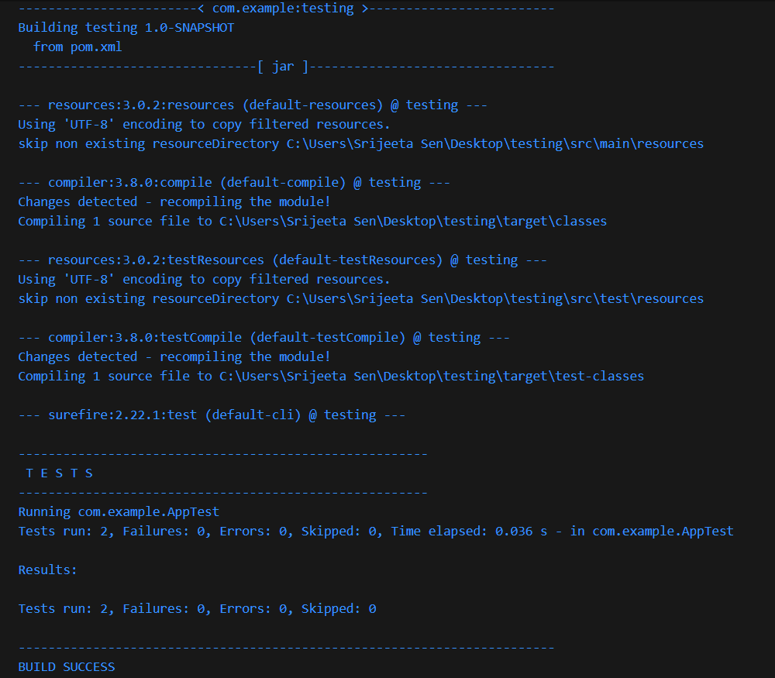

Exercise 2: Writing Basic JUnit Tests

Scenario:

You need to write basic JUnit tests for a simple Java class.

Steps:

1. Create a new Java class with some methods to test.

2. Write JUnit tests for these methods.

pom.xml

<?xml version="1.0" encoding="UTF-8"?>

<project xmlns="http://maven.apache.org/POM/4.0.0" xmlns:xsi="http://www.w3.org/2001/XMLSchema-instance"

  xsi:schemaLocation="http://maven.apache.org/POM/4.0.0 http://maven.apache.org/xsd/maven-4.0.0.xsd">

  <modelVersion>4.0.0</modelVersion>

  <groupId>com.example</groupId>

  <artifactId>calculator</artifactId>

  <version>1.0-SNAPSHOT</version>

  <name>calculator</name>

  <!-- FIXME change it to the project's website -->

  <url>http://www.example.com</url>

  <properties>

    <project.build.sourceEncoding>UTF-8</project.build.sourceEncoding>

    <maven.compiler.source>1.8</maven.compiler.source>

    <maven.compiler.target>1.8</maven.compiler.target>

  </properties>

  <dependencies>

    <dependency>

      <groupId>junit</groupId>

      <artifactId>junit</artifactId>

      <version>4.11</version>

      <scope>test</scope>

    </dependency>

  </dependencies>

  <build>

    <pluginManagement><!-- lock down plugins versions to avoid using Maven defaults (may be moved to parent pom) -->

      <plugins>

        <!-- clean lifecycle, see https://maven.apache.org/ref/current/maven-core/lifecycles.html#clean_Lifecycle -->

        <plugin>

          <artifactId>maven-clean-plugin</artifactId>

          <version>3.1.0</version>

        </plugin>

        <!-- default lifecycle, jar packaging: see https://maven.apache.org/ref/current/maven-core/default-bindings.html#Plugin_bindings_for_jar_packaging -->

        <plugin>

          <artifactId>maven-resources-plugin</artifactId>

          <version>3.0.2</version>

        </plugin>

        <plugin>

          <artifactId>maven-compiler-plugin</artifactId>

          <version>3.8.0</version>

        </plugin>

        <plugin>

          <artifactId>maven-surefire-plugin</artifactId>

          <version>2.22.1</version>

        </plugin>

        <plugin>

          <artifactId>maven-jar-plugin</artifactId>

          <version>3.0.2</version>

        </plugin>

        <plugin>

          <artifactId>maven-install-plugin</artifactId>

          <version>2.5.2</version>

        </plugin>

        <plugin>

          <artifactId>maven-deploy-plugin</artifactId>

          <version>2.8.2</version>

        </plugin>

        <!-- site lifecycle, see https://maven.apache.org/ref/current/maven-core/lifecycles.html#site_Lifecycle -->

        <plugin>

          <artifactId>maven-site-plugin</artifactId>

          <version>3.7.1</version>

        </plugin>

        <plugin>

          <artifactId>maven-project-info-reports-plugin</artifactId>

          <version>3.0.0</version>

        </plugin>

      </plugins>

    </pluginManagement>

  </build>

</project>

Calculator.java

package com.example;

public class Calculator {

    // A method that adds two numbers

    public int add(int a, int b) {

        return a + b;

    }

    // A method that multiplies two numbers

    public int multiply(int a, int b) {

        return a * b;

    }

    // A method that checks if a number is even

    public boolean isEven(int num) {

        return num % 2 == 0;

    }

}

CalculatorTest.java

package com.example;

import static org.junit.Assert.assertEquals;

import static org.junit.Assert.assertFalse;

import static org.junit.Assert.assertTrue;

import org.junit.Test;

public class CalculatorTest {

    @Test

    public void testAdd() {

        Calculator calculator = new Calculator();

        int sum = calculator.add(2, 3);

        assertEquals(5, sum);  // expects 2 + 3 = 5

    }

    @Test

    public void testMultiply() {

        Calculator calculator = new Calculator();

        int product = calculator.multiply(4, 5);

        assertEquals(20, product);  // expects 4 * 5 = 20

    }

    @Test

    public void testIsEven() {

        Calculator calculator = new Calculator();

        assertTrue(calculator.isEven(10));  // 10 is even

        assertFalse(calculator.isEven(7));  // 7 is not even

    }

}

Output

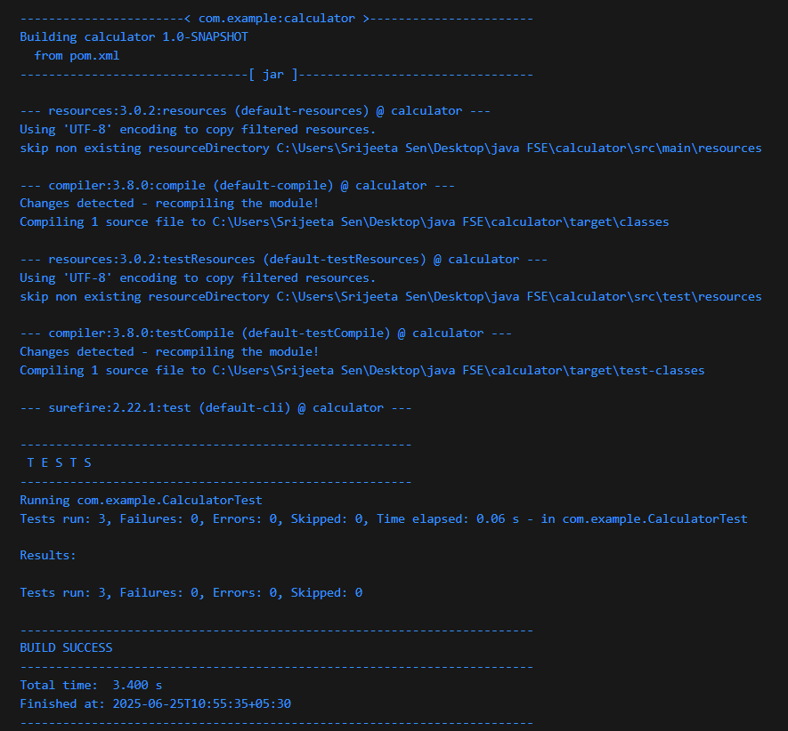

Exercise 3: Assertions in JUnit

Scenario:

You need to use different assertions in JUnit to validate your test results.

Steps:

1. Write tests using various JUnit assertions.

AssertionTest.java

public class AssertionsTest {

@Test

public void testAssertions() {

// Assert equals

assertEquals(5, 2 + 3);

// Assert true

assertTrue(5 > 3);

// Assert false

assertFalse(5 < 3);

// Assert null

assertNull(null);

// Assert not null

assertNotNull(new Object());

}

}

Output

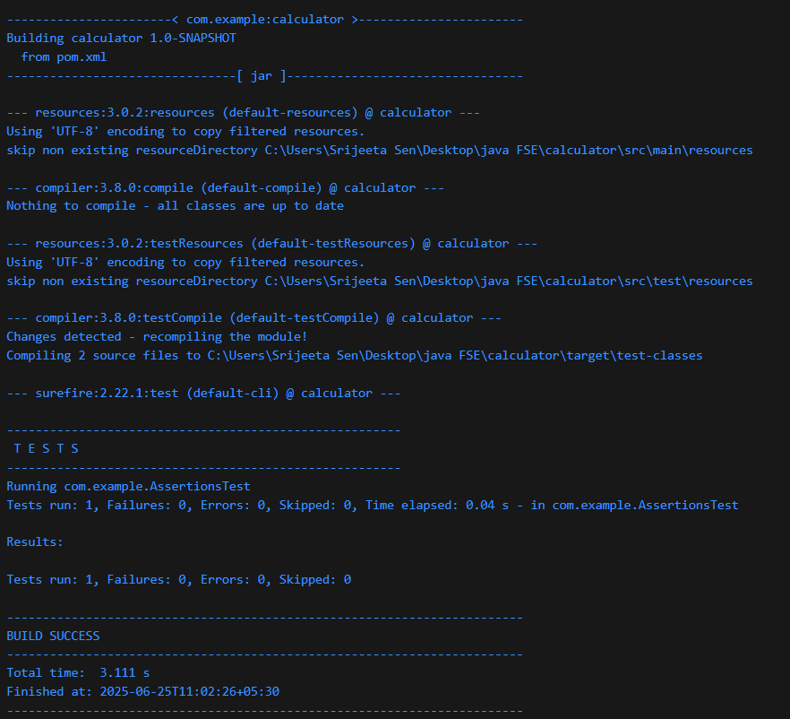

Exercise 4: Arrange-Act-Assert (AAA) Pattern, Test Fixtures, Setup and

Teardown Methods in JUnit

Scenario:

You need to organize your tests using the Arrange-Act-Assert (AAA) pattern and use setup

and teardown methods.

Steps:

1. Write tests using the AAA pattern.

2. Use @Before and @After annotations for setup and teardown methods.

Calculator.java

package com.example;

public class Calculator {

    public int add(int a, int b) {

        return a + b;

    }

    public int subtract(int a, int b) {

        return a - b;

    }

}

CalculatorTest.java

package com.example;

import org.junit.After;

import static org.junit.Assert.assertEquals;

import org.junit.Before;

import org.junit.Test;

public class CalculatorTest {

    private Calculator calculator;

    // This will run before every @Test

    @Before

    public void setUp() {

        calculator = new Calculator();

        System.out.println("Setting up Calculator instance...");

    }

    // This will run after every @Test

    @After

    public void tearDown() {

        calculator = null;

        System.out.println("Cleaning up Calculator instance...");

    }

    @Test

    public void testAdd() {

        // Arrange

        int a = 5;

        int b = 3;

        // Act

        int result = calculator.add(a, b);

        // Assert

        assertEquals(8, result);

    }

    @Test

    public void testSubtract() {

        // Arrange

        int a = 10;

        int b = 4;

        // Act

        int result = calculator.subtract(a, b);

        // Assert

        assertEquals(6, result);

    }

}

Output

